**Library Management System**

This System is for monitoring and controlling the transactions in a library, which mainly focuses on basic operations in a library like adding new member, new books, and updating new information, searching books and members and facility to borrow and return books.

The software Library Management System has four main objective.

Insertion to Database

Extracting from Database

Report Generation - borrowed book list

Search Facility system

**SYSTEM ANALYSIS**

**EXISTING SYSTEM:**

In our existing system all the transaction of books are done manually, So taking more time for a transaction like borrowing a book or returning a book and also for searching of members and books. Another major disadvantage is that to preparing the list of books borrowed in the library will take more time, currently it is doing as a one day process for verifying all records. So after conducting the feasibility study we decided to make the manual Library management system to be computerized.

**PROPOSED SYSTEM**

Proposed system is an automated Library Management System. Through our system admin can add members, add books, search members, search books, update information, edit information, borrow and return books in quick time.

Other members can search for their required books. Our proposed system has the following advantages.

* User friendly interface
* Fast access to database
* Less error
* More Storage Capacity
* Search facility
* Quick transaction

All the manual difficulties in managing the Library have been rectified by implementing computerization.

**Use Case Diagram**

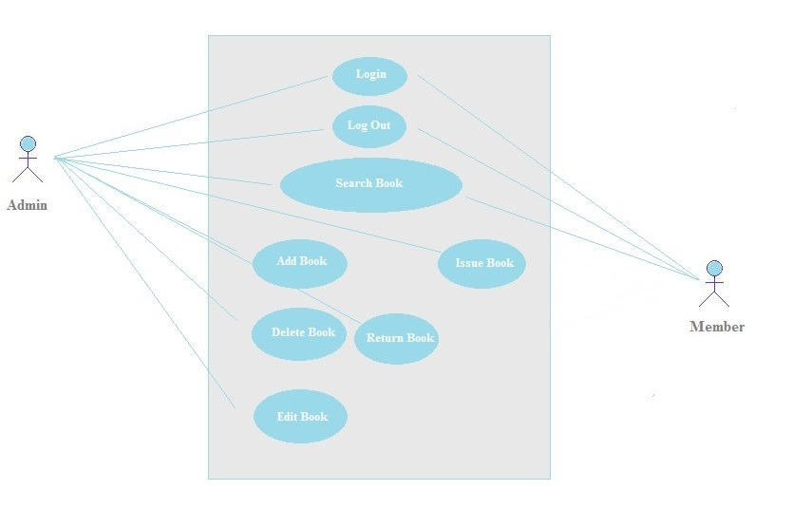

**ER Diagram**

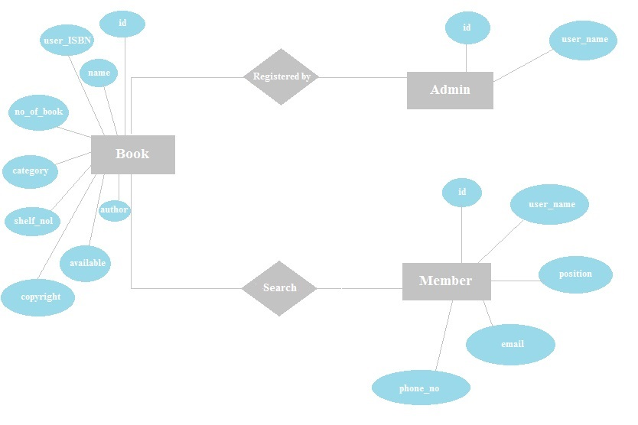

Login page for Admin:

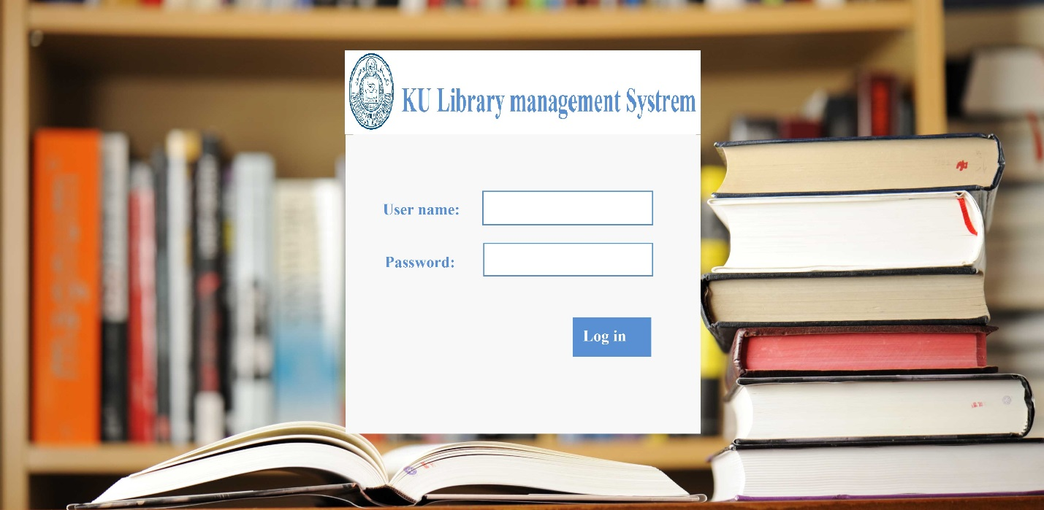

Home page:

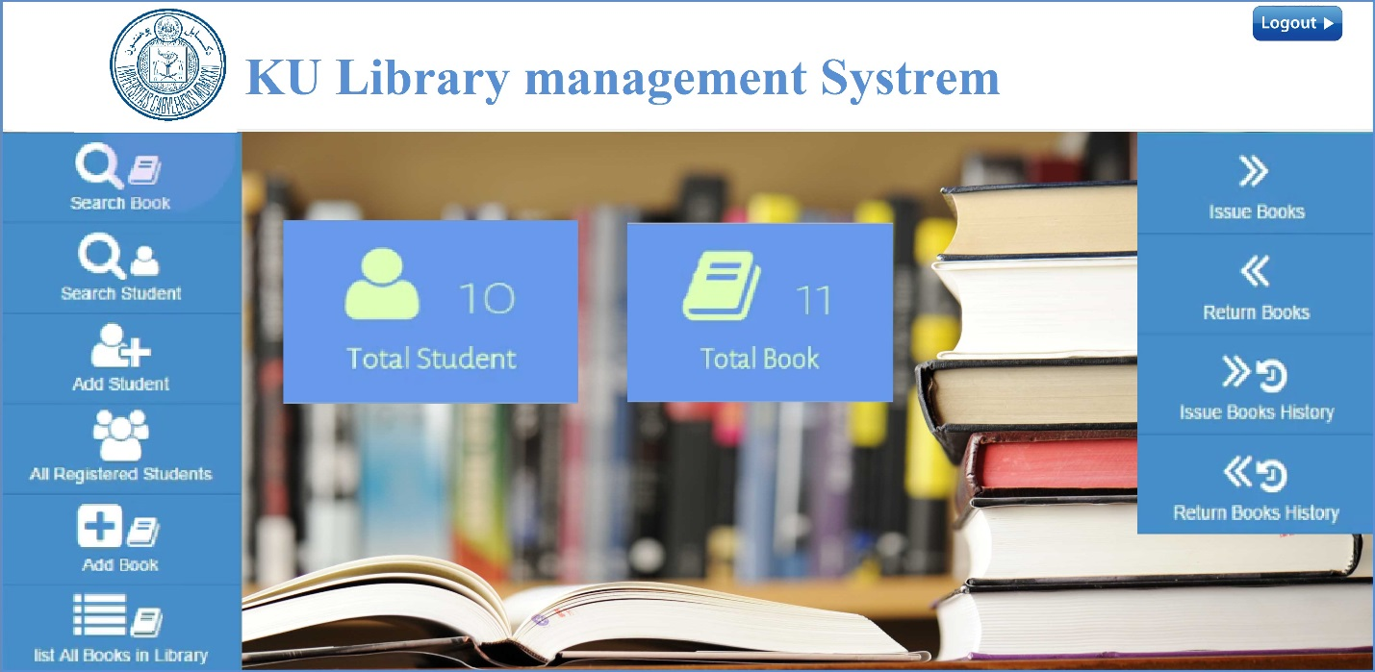

Search for Books:

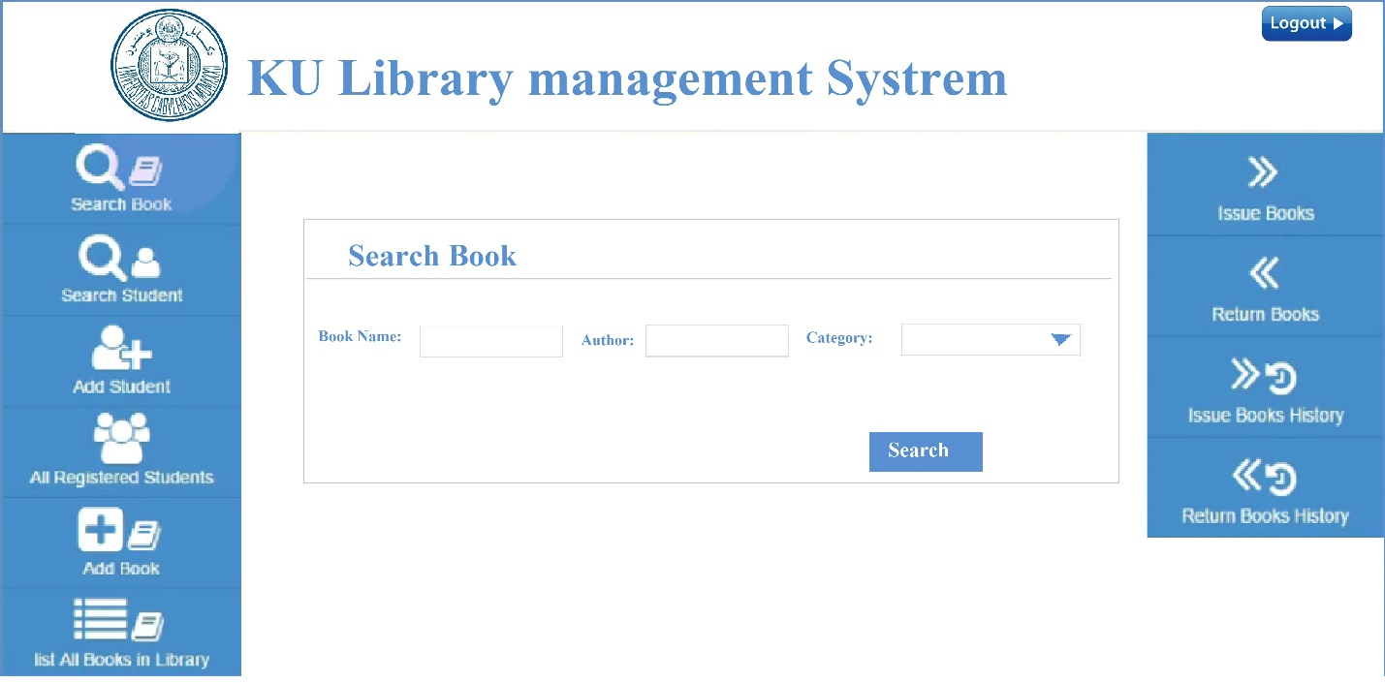

Search for Members:

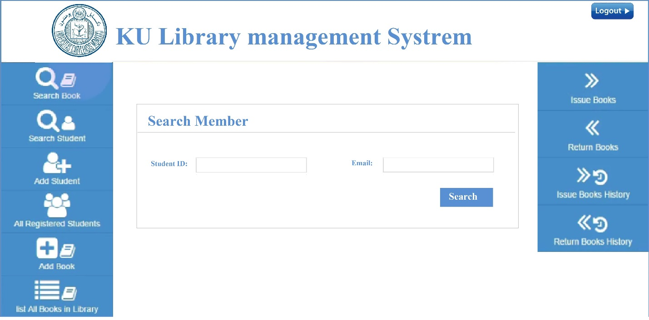

Add Member:

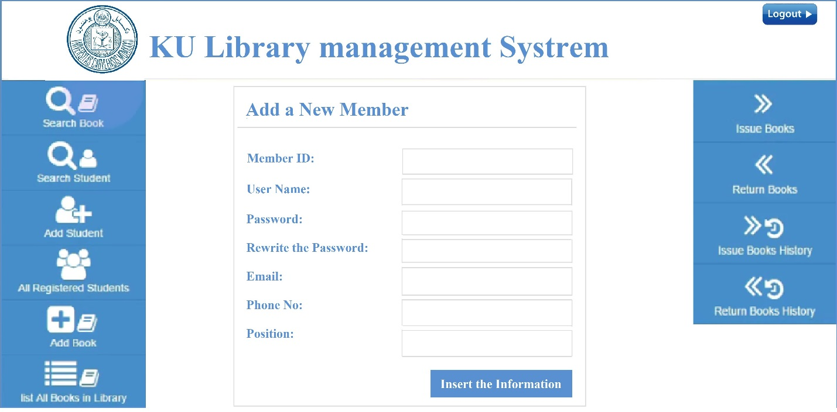

List of all Registered Members:

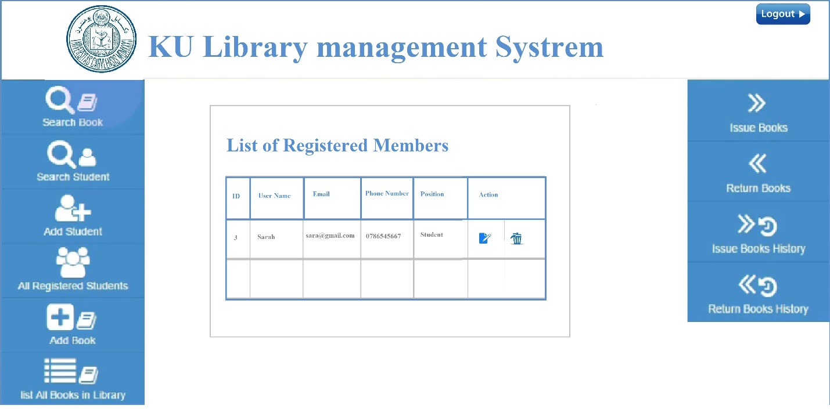

Add Book:

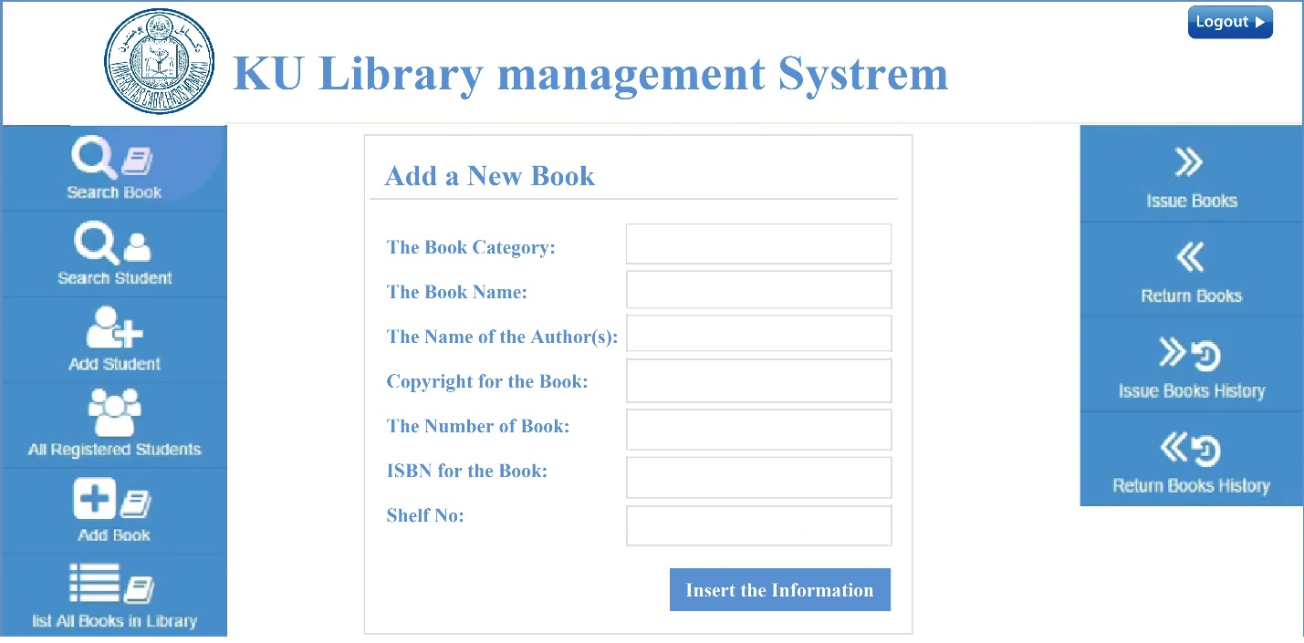

List of all Registered Books:

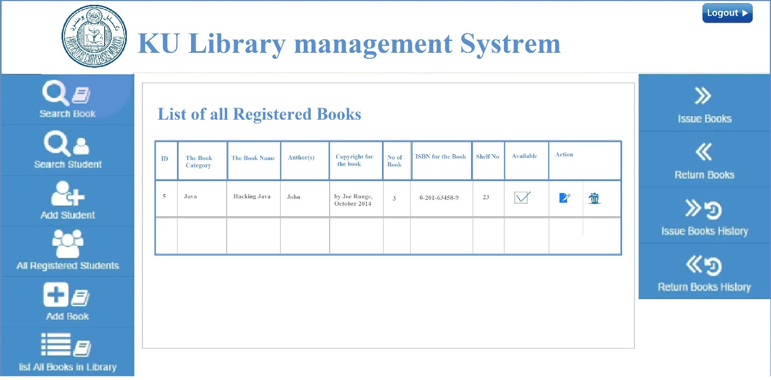

Issue Book:

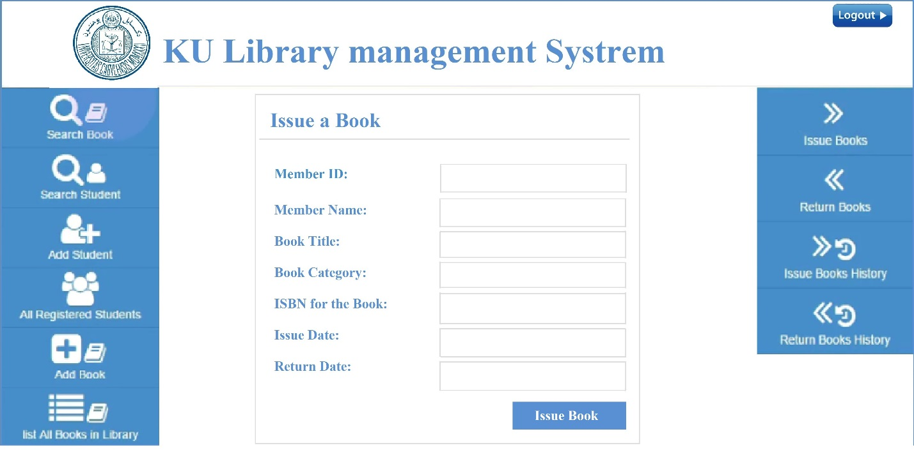

Issued Books History:

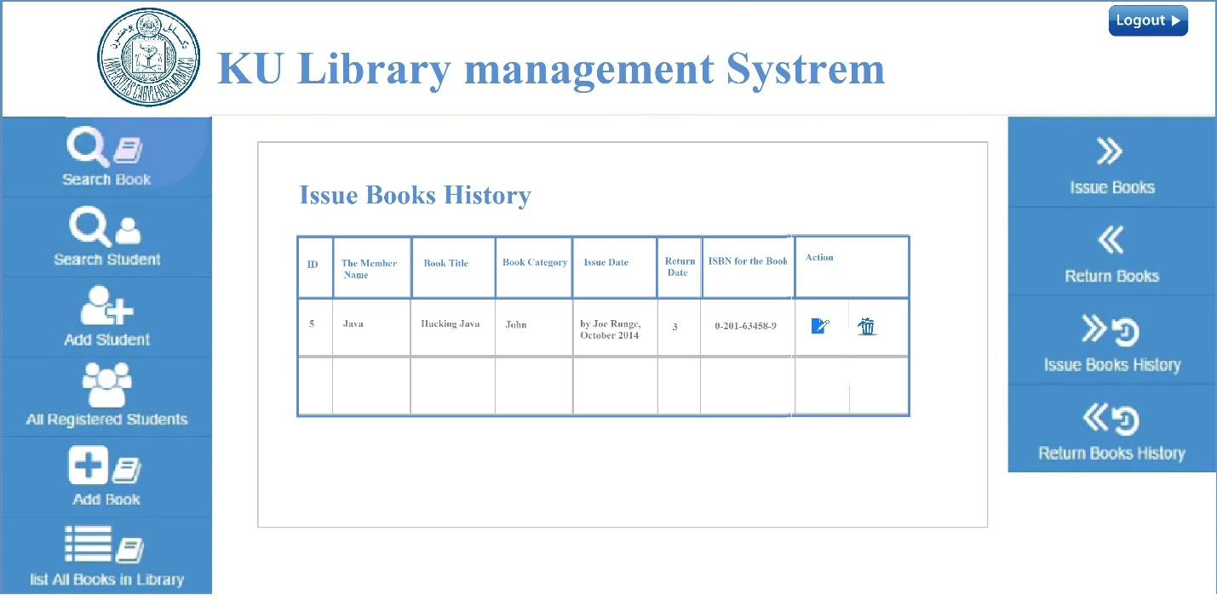

Return Book:

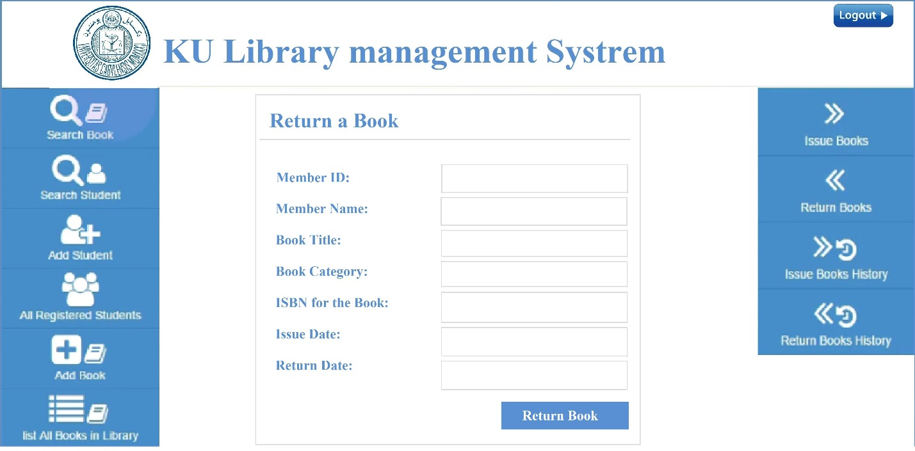

Return Book History:

